AFTERMATH
EDUBRIDGE
Project Concept & System Requirements Document
Version 0.1 — Concept Baseline
13 August 2026
“Think. Brainstorm. Develop. Deploy.”

Document Purpose
This document establishes the current concept, scope, requirements, architecture direction, stakeholders, and future development roadmap for EduBridge, an education technology platform being developed as a project under AfterMath. It consolidates the product vision discussed to date. It is a living baseline: detailed technical specifications, legal agreements, external integrations, budgets, and implementation decisions will be refined during later Software Development Life Cycle (SDLC) phases.

1. Executive Summary
EduBridge is envisioned as a web, Android, and iOS education ecosystem designed to help bridge education gaps by connecting learners, parents, teachers, artificial intelligence (AI), learning resources, external certifications, career guidance, and future education opportunities.
EduMindAi is the intelligence and teaching engine of EduBridge—the “mind of the Bridge.” It is intended to provide personalized, conversational, multimodal tutoring; understand how an individual learner learns; monitor learning engagement and understanding; adapt activities; provide learning breaks; support assessment readiness; and help connect learners with teachers and parents.
The platform will initially focus strongly on Basic Education, especially Grade 12, while creating pathways into external certifications, university applications, and career development.

2. Product Vision
To build an accessible, personalized and connected digital education ecosystem in which every learner can receive appropriate academic support, remain connected to teachers and parents, understand their educational progress, and move confidently from school into further education, certifications and careers.

3. Core Philosophy
- EduBridge is the ecosystem; EduMindAi is its intelligence and teaching engine.
- AI should extend teachers rather than replace them.
- Parents should have meaningful visibility and ways to support their children.
- Learners should have flexibility without being allowed to avoid academic accountability indefinitely.
- Learning should adapt to the learner instead of expecting every learner to adapt to one teaching style.
- Social interaction should encourage learning, motivation and safe peer connection.
- Security, privacy and child safety must be foundational requirements.
- EduBridge should support the learner beyond Grade 12 into certifications, higher education and career pathways.

4. Problem Statement
Learners may have unequal access to individual academic support, teachers have limited time to provide one-on-one explanations to every learner, parents may receive limited or delayed visibility into academic and behavioural issues, and learners can struggle to connect school performance with realistic future study and career options. EduBridge seeks to address these gaps by creating a connected environment where AI, teachers, parents and learners can collaborate.

5. Stakeholders and User Roles
Stakeholder / Role | Primary Responsibilities | Key Needs
Learner | Study, complete topics, practice, take assessments, communicate, pursue extra learning | Personalized teaching, progress visibility, engagement, safe community
Parent/Guardian | Monitor progress, set study schedules, communicate, support and purchase eligible courses | Clear progress, alerts, communication, control and transparency
Teacher | Teach Basic Education content, create assessments, review progress, intervene | Efficient tools, learner insights, assessment and parent communication
EduMindAi | Personalized tutoring, learner modelling, engagement support, readiness analysis | Secure data, learning context, reliable AI services
AfterMath | Own/manage product, develop, operate, support, improve and commercialize platform | Sustainable architecture, security, scalability, IP protection
Government / Department of Basic Education | Potential strategic partner, funder, deployment/pilot stakeholder | Education outcomes, governance, accountability, security
External Course/Certification Provider | Provide additional learning/certification opportunities | Integration, payments, eligibility and verification
University/College | Potential application and programme destination | Accurate application data and published requirements
System Administrator | Platform operations, security, moderation and support | Monitoring, auditability, controlled access

6. Major Platform Modules
- Learner Learning Hub — Basic Education resources, lessons, videos, notes, activities, quizzes and practice.
- EduMindAi — personalized AI tutoring, conversational support, learner model and adaptive learning.
- Teacher Classroom — classes, content, assessments, learner insights, teacher explanation videos and interventions.
- Parent Portal — progress, reports, schedules, notifications, communication and eligible purchases.
- Assessment Engine — topic completion, flexible combined assessments, readiness support and results.
- Community/Social Learning — follows, posts, study groups, safe chat, achievements and peer motivation.
- Game Room — brain games, quick games, educational games and challenges.
- Results Hub — term reports and, subject to official access/agreements, Grade 12 official results.
- Career & University Guidance — results/interests-based recommendations and application support.
- External Courses & Certifications — additional courses and certificates such as technology and professional skills.
- Payments & Store — payment gateway for eligible digital purchases and potential EduBridge merchandise.
- Security & Trust Layer — identity, access control, encryption, monitoring, abuse prevention and recovery.
- Administration & Analytics — operations, moderation, reporting, system health and controlled platform management.

7. EduMindAi Requirements

7.1 Personalized Learner Model
During onboarding, the learner can complete personalized questions and activities that help EduMindAi understand preferences, interests and learning behaviour. The model should evolve from observed interaction rather than treating the onboarding questionnaire as a permanent label.
- Preferred explanation style and modality.
- Learning pace and response patterns.
- Topic strengths and weaknesses.
- Engagement and attention patterns.
- Interests such as sport, music, technology, politics or games.
- Patterns indicating when long study sessions may be reducing learning effectiveness.
- Assessment history and demonstrated mastery.
EduMindAi must not independently diagnose medical conditions such as ADHD. Where relevant, a parent/learner may voluntarily disclose an existing diagnosis, while the system separately models learning behaviour for personalization.

7.2 Conversational Teaching
- Support text and voice interactions.
- Use simple, learner-appropriate explanations.
- Ask clarifying questions to understand what the learner actually does not understand.
- Adapt the explanation after each learner response.
- Use examples, visuals and interactive activities where appropriate.
- Maintain context so the learner can continue a teaching conversation rather than repeatedly restarting.
Voice over Internet Protocol (VoIP) or comparable real-time voice technology may be used for natural voice interaction, subject to technical, privacy and cost validation.

7.3 Learning Fatigue and Engagement
When the system detects a significant decline in learning performance or engagement, it may recommend a Learning Pause instead of continuously presenting academic content.
- Short brain or memory games.
- Logic and pattern games.
- Trivia and quick challenges.
- Educational mini-games.
- Interest-based conversation with EduMindAi.
- Optional return-to-learning prompt after the break.
The system should use supportive language such as “Learning Pause” or “Brain Break” rather than framing the intervention as punishment or force.

8. Learning and Assessment Model

8.1 Topic Completion
Every learning topic includes a Complete Topic action. Completion records that the learner has finished the learning pathway for that topic; it does not automatically force an assessment.

8.2 Flexible Assessment
Learners may choose to assess immediately or continue to another completed topic and combine topics into a larger assessment. The current product concept proposes a maximum of approximately three completed topics before an assessment becomes required, preventing indefinite assessment avoidance while avoiding a repetitive test after every topic.
EduMindAi may recommend targeted revision before an assessment when evidence suggests insufficient understanding.
Target learning loop: Learn → Practice → Complete → Choose assessment timing → AI readiness support → Assess → Analyze → Improve.

9. Teacher–AI Collaboration
- Teachers create and issue Basic Education assessments.
- Teachers see performance and topic-level difficulty indicators.
- EduBridge can alert a teacher when a concept produces repeated learner confusion.
- Teachers can record short explanation videos addressing difficult questions/topics.
- Learners can receive both the teacher's human explanation and an EduMindAi explanation.
- Teachers remain responsible for educational judgement and intervention.

10. Parent Ecosystem
- View learner progress and assessment history.
- Receive term report notifications.
- See areas requiring attention.
- Set study schedules and session windows.
- Receive notifications when scheduled study begins/ends.
- Communicate with the learner through in-app chat.
- Communicate with teachers through the platform where appropriate.
- Receive information about behaviour/attendance concerns.
- Support or purchase eligible external courses/certifications.
- Access appropriate controls over the learner's account and privacy.
Parent controls should support children without turning EduBridge into an intrusive surveillance system. Sensitive academic and behavioural information should be protected by role-based access and privacy rules.

11. Community and Social Learning
- Learners can follow other learners where permitted.
- Safe peer-to-peer chat and educational groups.
- Posts about learning activities, achievements and interests.
- Study groups and peer encouragement.
- Sharing badges/certificates and selected achievements.
- Educational challenges and games.
Because the platform is expected to serve minors, the social system requires strong moderation, reporting/blocking, age-appropriate controls, privacy protections, anti-bullying mechanisms and restrictions on inappropriate or unsolicited communication.

12. Reports, Results and Progress
- Teachers can publish term reports to learner/parent accounts.
- Learners and parents can review historical progress.
- Teachers can add appropriate comments and academic/behavioural observations.
- EduBridge may integrate official Grade 12 results through the authorized government/results provider, subject to availability, authorization and data-sharing requirements.
- Learners may share a verified achievement/result status within the EduBridge community without exposing sensitive academic information by default.

13. Career Guidance and University Applications
EduBridge should connect school performance and learner interests to future pathways.
- Analyze subjects, results, interests and relevant achievements.
- Suggest career fields and related courses.
- Show programmes for which the learner appears to meet published academic requirements.
- Show universities/institutions offering relevant programmes.
- Clearly distinguish eligibility indicators from guaranteed admission.
- Where supported by official institutions and agreements, assist learners with university applications.
- Reuse verified profile information where legally and technically permitted.
The system must avoid promising admission. Recommendations should be based on current, authoritative programme requirements and should communicate uncertainty and institutional selection rules.

14. External Courses and Certifications
- Offer additional learning opportunities beyond Basic Education.
- Potential categories include IT, programming, networking, cybersecurity, AI, entrepreneurship and digital skills.
- Potential integrations/providers may include organizations such as CompTIA and Coursera, subject to commercial and technical agreements.
- Parents or learners may purchase eligible courses/certifications through supported payment flows.
- Certificates and verified achievements may be stored and selectively shared.

15. Security and Trust Layer
EduBridge must use defence-in-depth rather than promising that the platform is impossible to hack.
- Strong authentication and optional/required multi-factor authentication for appropriate roles.
- Role-based access control.
- Encryption in transit and at rest for sensitive information.
- Secure API gateway and service-to-service authentication.
- Rate limiting, abuse prevention and bot protection.
- Web Application Firewall (WAF) and Distributed Denial-of-Service (DDoS) protection where appropriate.
- Secure session and device management.
- Audit logs and security monitoring.
- Vulnerability scanning and penetration testing.
- Secure software development practices and dependency management.
- Separation of development, testing and production environments.
- Backups, disaster recovery and incident response.
- Data minimization, retention controls and privacy-by-design.
- Special protection for child and learner data.
- Strict access controls for AI services and administrative systems.

16. Technology and System Architecture Direction
A service-oriented architecture is recommended so that major capabilities can scale independently. Final technology choices should be validated during requirements and architecture phases.
- Web client for learners, parents, teachers and administrators.
- Android and iOS mobile clients.
- Backend/API layer for authentication, users, learning, assessments, reports, community, payments and integrations.
- EduMindAi service layer for tutoring, personalization and learner analytics.
- Database layer for structured platform data.
- Object/media storage for videos, documents and certificates.
- Real-time communication service for chat/voice where required.
- Notification service for reminders and alerts.
- External integration layer for certification providers, results systems and university/application services.
- Observability stack for performance, errors, security events and capacity.

17. Scalability and Pilot Deployment
A pilot should test EduBridge in real South African school environments before large-scale deployment.
- Include schools with different connectivity conditions.
- Include urban and rural environments where feasible.
- Test different devices and network providers.
- Measure concurrent users, response time and system stability.
- Test AI API consumption and cost.
- Test video and voice performance.
- Test database and storage scaling.
- Conduct controlled load/stress tests that simulate large numbers of simultaneous users.
- Measure learner, teacher and parent usability.
- Collect teacher feedback and iterate.
A staged pilot could grow from small cohorts to hundreds and then thousands of concurrent users. The exact numbers should be determined from infrastructure capacity, budget and pilot agreements.

18. Teacher Enablement
If a government or school partnership is established, AfterMath can provide structured EduBridge teacher seminars.
- Platform orientation.
- Teacher dashboard training.
- Assessment creation and management.
- Learner-progress interpretation.
- Teacher video explanation workflow.
- EduMindAi collaboration.
- Parent communication.
- Privacy, safety and responsible AI practices.
- Practical workshops and feedback sessions.

19. Government Partnership Direction
AfterMath may explore engagement with the South African Department of Basic Education or relevant public-sector stakeholders. The intended direction is a strategic partnership, pilot, funding arrangement, procurement arrangement, or deployment partnership rather than automatically transferring complete ownership of EduBridge.
- AfterMath should seek to retain product and intellectual-property ownership unless a negotiated agreement states otherwise.
- Public-sector funding could support infrastructure, AI services, development, security, deployment, training and operations.
- Pilot outcomes should provide measurable evidence before expansion.
- All data-sharing, procurement, compliance, security and ownership arrangements require appropriate legal and institutional review.

20. Business and Revenue Model
- Potential subscription or institutional licensing models.
- Government/school deployment or procurement arrangements.
- Revenue share or integration arrangements with external course/certification providers.
- Payment gateway fees and eligible digital purchases.
- Potential EduBridge merchandise store: bottles, lunch boxes, hoodies, bags, stationery and related products.
- Enterprise or partner services where appropriate.
Education access and core learner support should remain the primary product purpose. Commercial features should not undermine learner safety, fairness or educational outcomes.

21. Key Non-Functional Requirements
Requirement | Direction
Security | Defence-in-depth, secure authentication, authorization, monitoring and recovery.
Privacy | Privacy-by-design and strict protection of learner/child data.
Scalability | Architecture capable of handling large concurrent school populations.
Availability | High availability for core learning and assessment services, with defined service targets later.
Performance | Fast responses under normal and peak conditions; measurable performance budgets later.
Accessibility | Accessible interfaces across devices and suitable for diverse learners.
Usability | Simple, engaging, learner-friendly interfaces.
Maintainability | Modular services, documented APIs, testing and deployment automation.
Reliability | Transactional integrity for assessments, reports, payments and certificates.
Auditability | Important actions and administrative/security events should be auditable.
Interoperability | API-first integration with approved external services.
Responsible AI | Human oversight, transparency about AI limitations, safety and monitoring.

22. Initial Use Case Catalogue
- Register/Login as Learner.
- Complete learner onboarding profile.
- Study a Basic Education topic.
- Ask EduMindAi a question.
- Have a voice conversation with EduMindAi.
- Complete a topic.
- Choose when to take an assessment.
- Take a combined assessment.
- Receive targeted revision.
- View assessment results.
- Receive a Learning Pause recommendation.
- Play a game or take a brain break.
- View teacher explanation video.
- Join a study group.
- Create/view a learning post.
- Chat with permitted peers.
- View term report.
- Parent views learner progress.
- Parent sets study schedule.
- Parent receives study notification.
- Parent chats with learner.
- Teacher creates assessment.
- Teacher views learner analytics.
- Teacher records explanation video.
- Teacher communicates with parent.
- Publish term report.
- Access official Grade 12 results where integration is authorized.
- Share a verified achievement.
- Receive career recommendations.
- Explore university programmes.
- Apply to a university where supported.
- Purchase eligible course/certification.
- View certificate.
- Use EduBridge store.
- Administrator manages platform, security and moderation.

23. Initial Data Model Direction
The eventual Entity Relationship Diagram (ERD) should be derived from detailed requirements. Likely core entities include:
- User
- Learner Profile
- Parent/Guardian Relationship
- Teacher
- School
- Class
- Subject
- Course
- Topic
- Learning Activity
- Topic Completion
- Assessment
- Assessment Question
- Assessment Attempt
- Result
- Term Report
- Teacher Comment
- Teacher Video
- Learning Event
- Learner Model/Preferences
- Interest
- Study Schedule
- Notification
- Chat Conversation
- Message
- Community Post
- Follow Relationship
- Study Group
- Game
- Achievement/Badge
- Certificate
- External Provider
- University
- Programme
- Application
- Payment
- Order
- Product
- Security/Audit Event

24. SDLC Direction
EduBridge should be developed using an iterative SDLC approach, with Agile practices suitable for continuous user feedback and pilot learning.
- Initiation & Feasibility — validate problem, stakeholders, funding, scope and risks.
- Requirements Analysis — convert this concept into functional/non-functional requirements and acceptance criteria.
- System Design — architecture, database, APIs, security, user experience and AI design.
- Development — build in modular increments.
- Testing — unit, integration, system, security, performance, usability and AI evaluation.
- Pilot Deployment — controlled real-school deployment.
- Evaluation — analyze technical and educational outcomes.
- Iteration — improve product based on evidence.
- Scaled Deployment — expand only after readiness and governance checks.
- Maintenance & Continuous Improvement — security updates, feature improvements and operational support.

25. Future Documentation Deliverables
- Software Requirements Specification (SRS).
- Stakeholder and requirements matrix.
- Use Case Diagram and detailed Use Case Specifications.
- Activity Diagrams.
- System Context Diagram.
- High-Level System Architecture Diagram.
- Deployment Architecture Diagram.
- Entity Relationship Diagram (ERD).
- Class Diagram where useful.
- Sequence Diagrams for critical workflows.
- API specification.
- Security threat model.
- Data-flow and privacy model.
- AI architecture and evaluation plan.
- Assessment engine specification.
- Pilot deployment plan.
- Teacher training plan.
- Test strategy and acceptance criteria.
- Risk register.
- Product roadmap.
- Business and partnership proposal.

26. Risks Requiring Early Attention
- Child safety and privacy.
- Cybersecurity and account compromise.
- AI hallucination or inaccurate educational explanations.
- Bias in learner profiling or recommendations.
- Unreliable internet/connectivity.
- High AI/voice/video infrastructure costs.
- Scalability during peak school usage.
- External API/provider availability and commercial changes.
- Official results and university integration permissions.
- Government procurement and partnership complexity.
- Teacher adoption and training requirements.
- Moderation of learner social content.
- Data ownership and intellectual-property disputes.
- Over-reliance on automated career or admission recommendations.

27. Product Principles for the First Build
- Build the learning core before expanding the social layer.
- Treat EduMindAi as a controlled educational service with human oversight.
- Design for low and variable connectivity from the beginning.
- Make security and privacy architectural requirements.
- Do not assume external government or university APIs exist; verify access before implementation.
- Use pilot evidence to guide scale.
- Keep learners at the centre of every feature decision.
- Keep teachers in control of educational judgement.
- Give parents visibility and support tools without excessive surveillance.
- Design the system so individual modules can evolve without rebuilding the whole platform.

28. Project Ownership
EduBridge is a project under AfterMath. The current strategic direction is for AfterMath to develop, manage, operate and improve the platform while retaining ownership of the product and intellectual property unless future contracts explicitly establish another arrangement. Any government, school, university, certification-provider or technology-provider relationship should be governed by written agreements defining licensing, data, security, responsibilities, funding and intellectual property.

29. Current Product Statement
EduBridge is an AfterMath-built education ecosystem that connects learners, parents, teachers, AI and future education opportunities. EduMindAi acts as the intelligence of the platform, providing personalized, conversational learning support while helping teachers understand learner needs. The platform aims to take a learner from Basic Education through assessment, achievement, Grade 12 results, career discovery, university applications and additional certifications—while maintaining a safe, secure and engaging environment.

30. Status of This Document
This is Version 0.1 and represents the concept baseline as of 13 August 2026. It is not yet a final Software Requirements Specification, legal agreement, procurement proposal or implementation contract. Detailed requirements, technical choices, data protection obligations, external integration permissions, budgets and acceptance criteria must be validated during subsequent SDLC phases.

Appendix A: SDLC Diagrams
This appendix presents the initial set of Software Development Life Cycle (SDLC) diagrams referenced in Section 25 (Future Documentation Deliverables): a Use Case Diagram, Activity Diagrams, a System Context Diagram, a High-Level System Architecture Diagram, a Deployment Architecture Diagram, an Entity Relationship Diagram (ERD), a simplified Class Diagram, and Sequence Diagrams for critical workflows.
These diagrams are conceptual and derived directly from the requirements captured in this Version 0.1 baseline (Sections 5–23). They are intended to visualize the current product concept and to guide subsequent SDLC phases (System Design, Development and Testing), not to represent final, validated technical specifications. Actor sets, entities, services and workflows will be refined as detailed requirements, architecture and data modelling work proceeds.
This appendix contains the following diagrams:
- Figure A.1 – Use Case Diagram (1 of 2): Learning, AI Tutoring & Classroom
- Figure A.2 – Use Case Diagram (2 of 2): Community, Career, Certification & Administration
- Figure A.3 – Activity Diagram: Learning & Assessment Loop
- Figure A.4 – Activity Diagram: Learning Fatigue & Pause Recommendation
- Figure A.5 – System Context Diagram (Level 0)
- Figure A.6 – High-Level System Architecture Diagram
- Figure A.7 – Deployment Architecture Diagram (Conceptual)
- Figure A.8 – Entity Relationship Diagram (Initial Data Model)
- Figure A.9 – Simplified Domain Class Diagram
- Figure A.10 – Sequence Diagram: EduMindAi Tutoring Conversation
- Figure A.11 – Sequence Diagram: Assessment Completion, Analytics & Notification

Use Case Diagram (1 of 2): Learning, AI Tutoring & Classroom
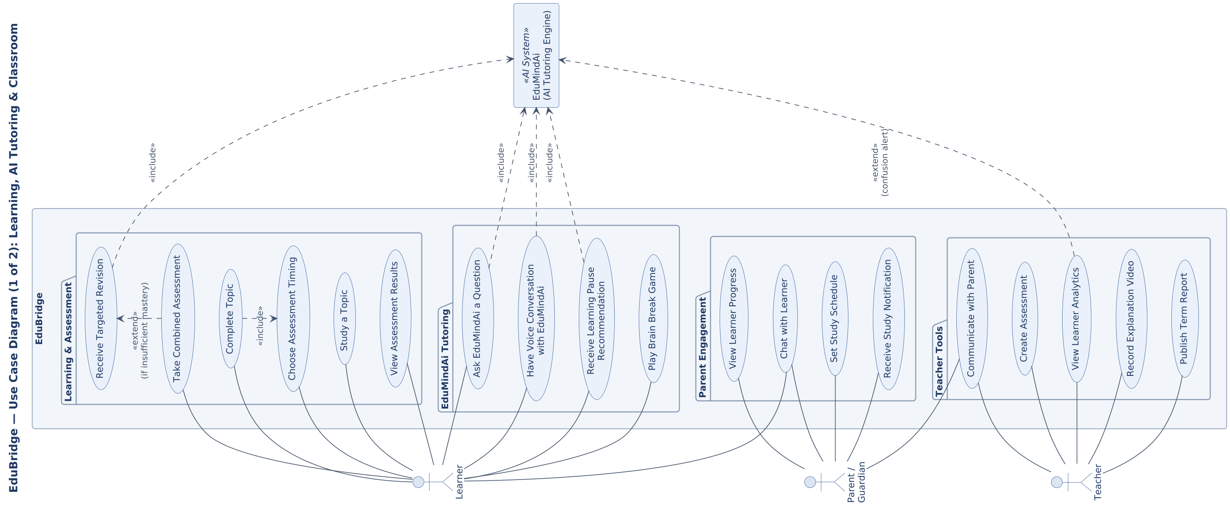
Figure A.1. Core learner, parent and teacher use cases centred on the Learning Hub, EduMindAi tutoring and Teacher Classroom modules (Sections 6–9). Page rotated 90° to maximize print size.

Use Case Diagram (2 of 2): Community, Career, Certification & Administration
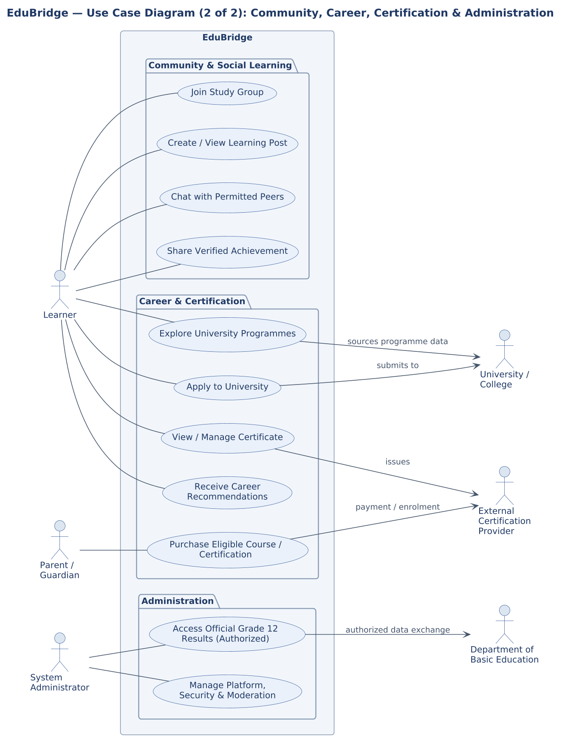
Figure A.2. Community/social learning, career & university guidance, external certification, and administration use cases, including external actors (Sections 11, 13–15).

Activity Diagram: Learning & Assessment Loop
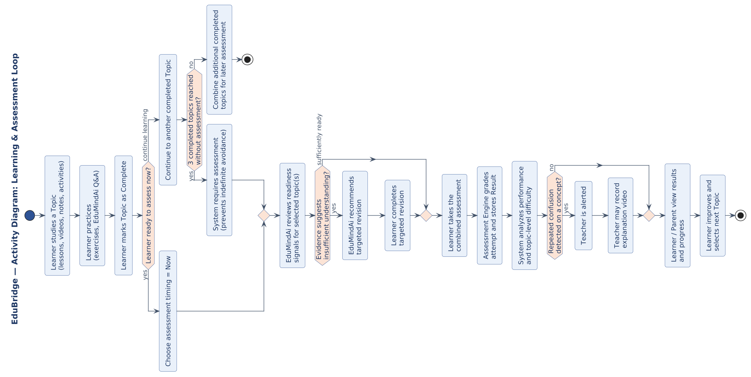
Figure A.3. Learn → Practice → Complete → Choose assessment timing → AI readiness support → Assess → Analyze → Improve, including the three-topic assessment trigger (Section 8). Page rotated 90° to maximize print size.

Activity Diagram: Learning Fatigue & Pause Recommendation
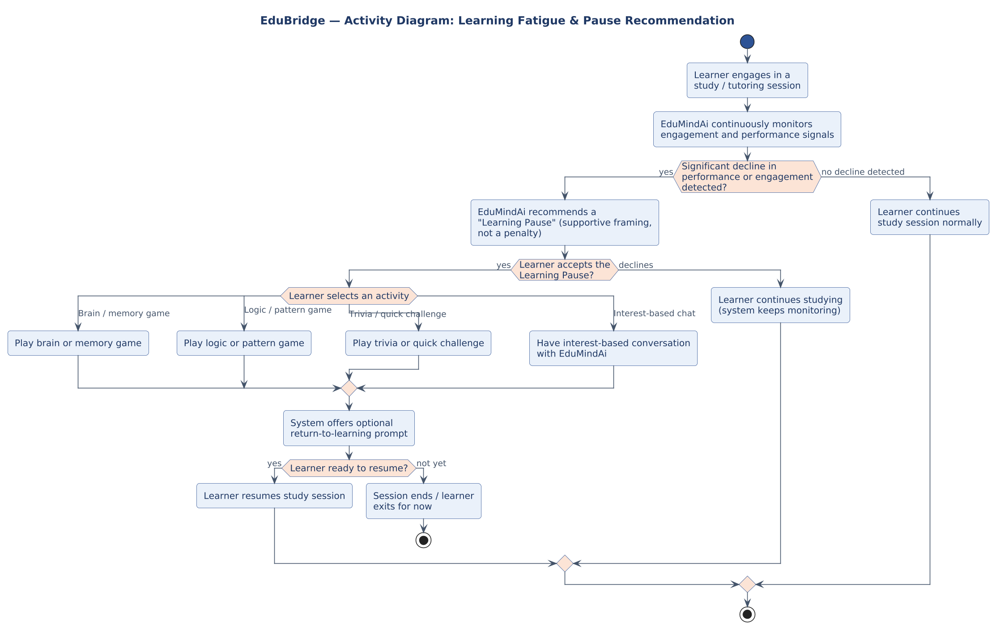
Figure A.4. Engagement monitoring and the supportive “Learning Pause” flow, including brain-break activity choices and the return-to-learning prompt (Section 7.3).

System Context Diagram (Level 0)
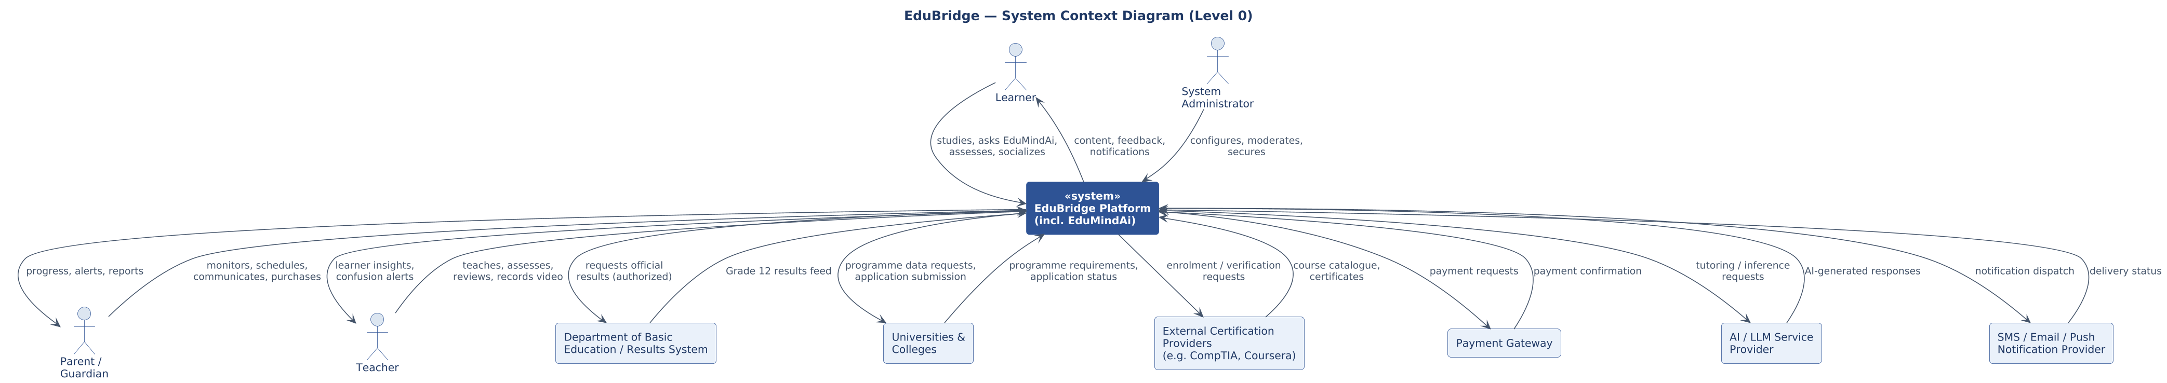
Figure A.5. EduBridge platform boundary showing all primary human actors and external systems it exchanges data with (Sections 5, 14–15, 19).

High-Level System Architecture Diagram
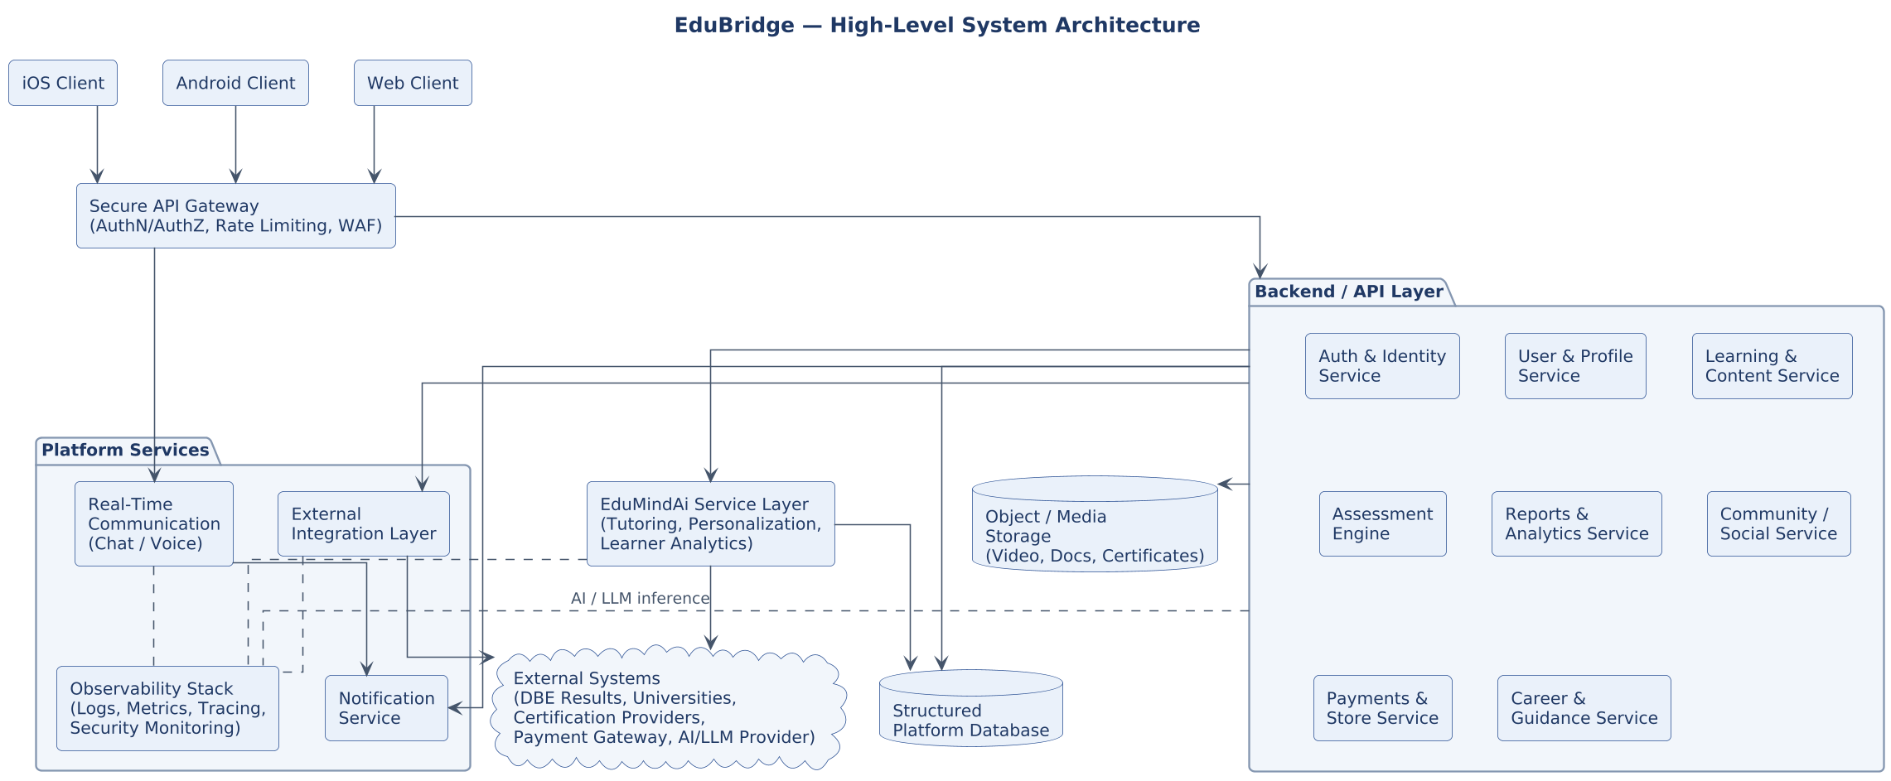
Figure A.6. Client, gateway, backend service, EduMindAi service, data/storage and platform-service layers described in the technology direction (Section 16).

Deployment Architecture Diagram (Conceptual)
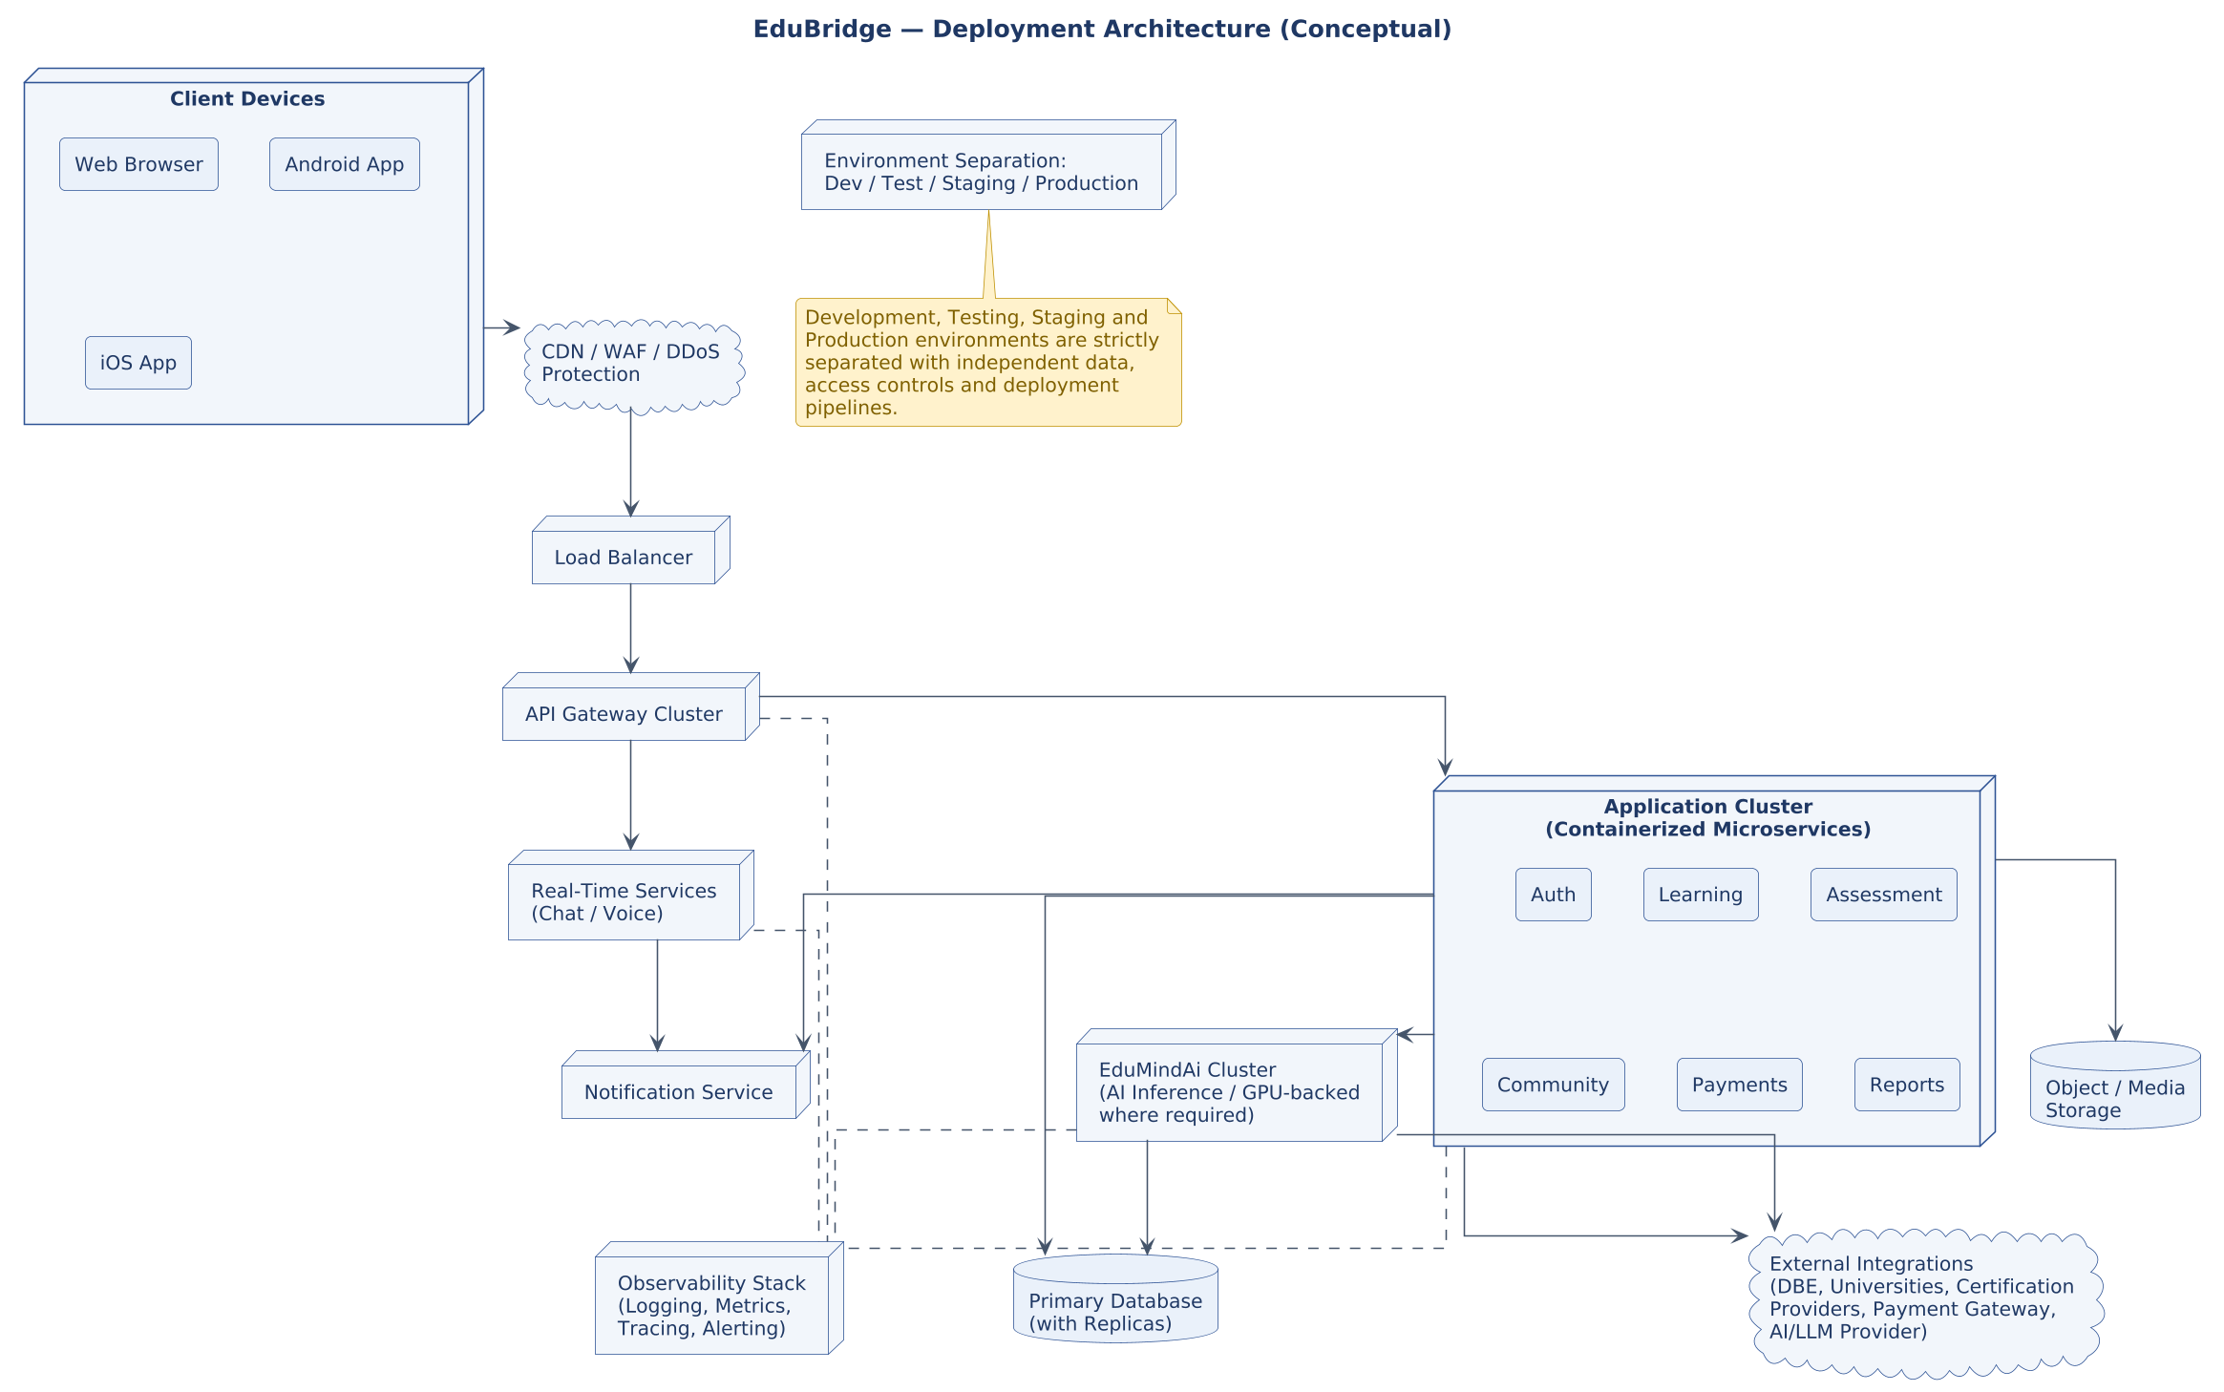
Figure A.7. Conceptual deployment topology from client devices through CDN/WAF, load balancing, containerized service clusters, data stores and external integrations, with environment separation (Sections 15–16).

Entity Relationship Diagram (Initial Data Model)
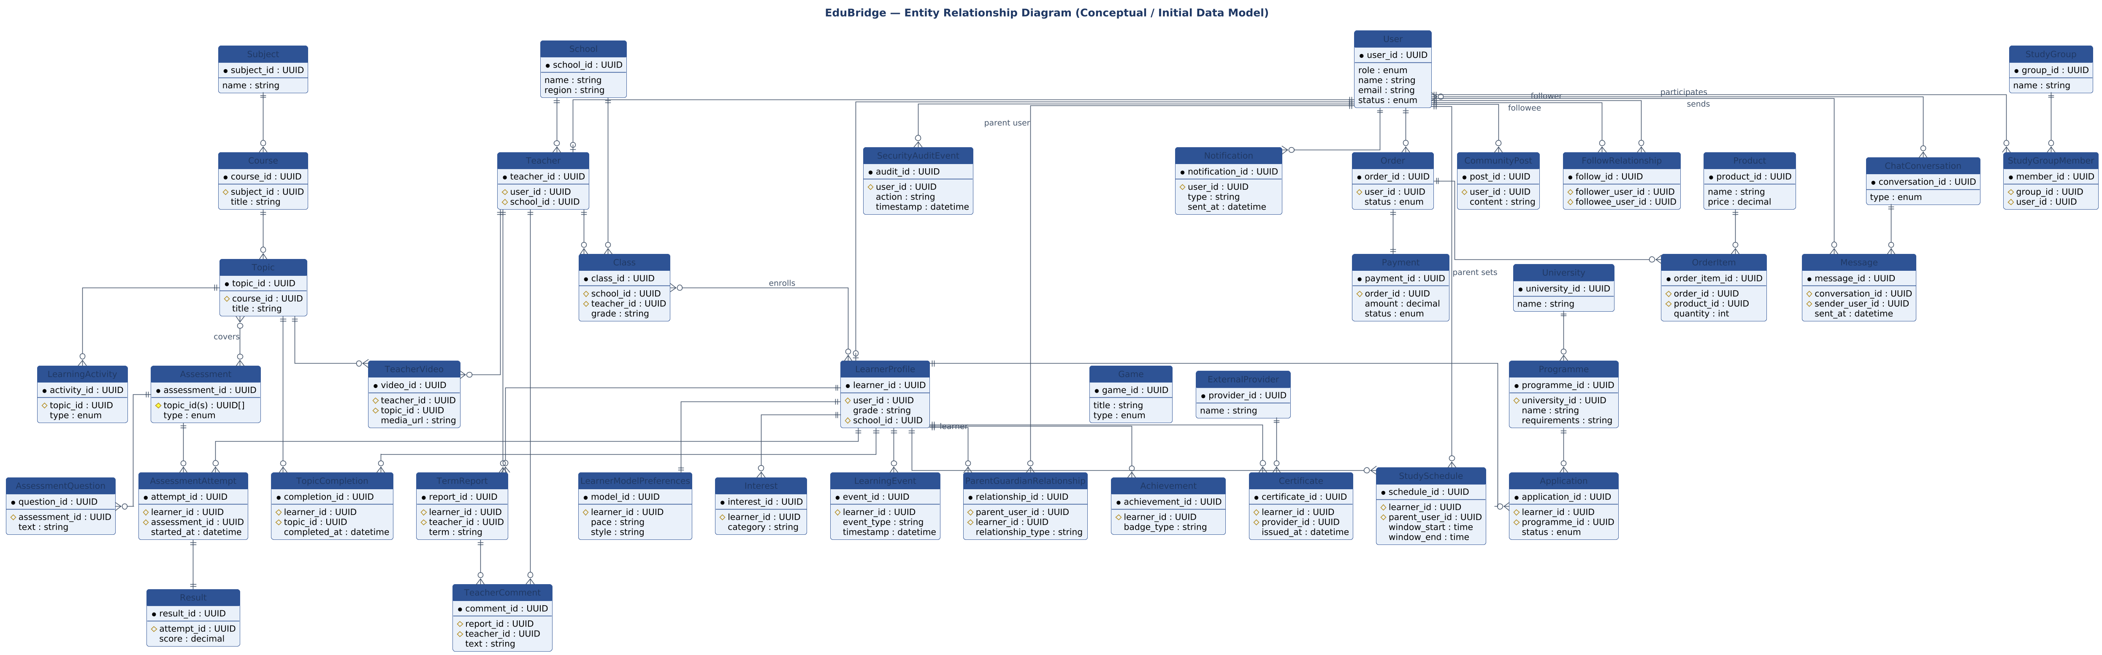
Figure A.8. Conceptual ERD derived from the core entities listed in Section 23. Cardinalities are indicative and will be refined during detailed data modelling.

Simplified Domain Class Diagram
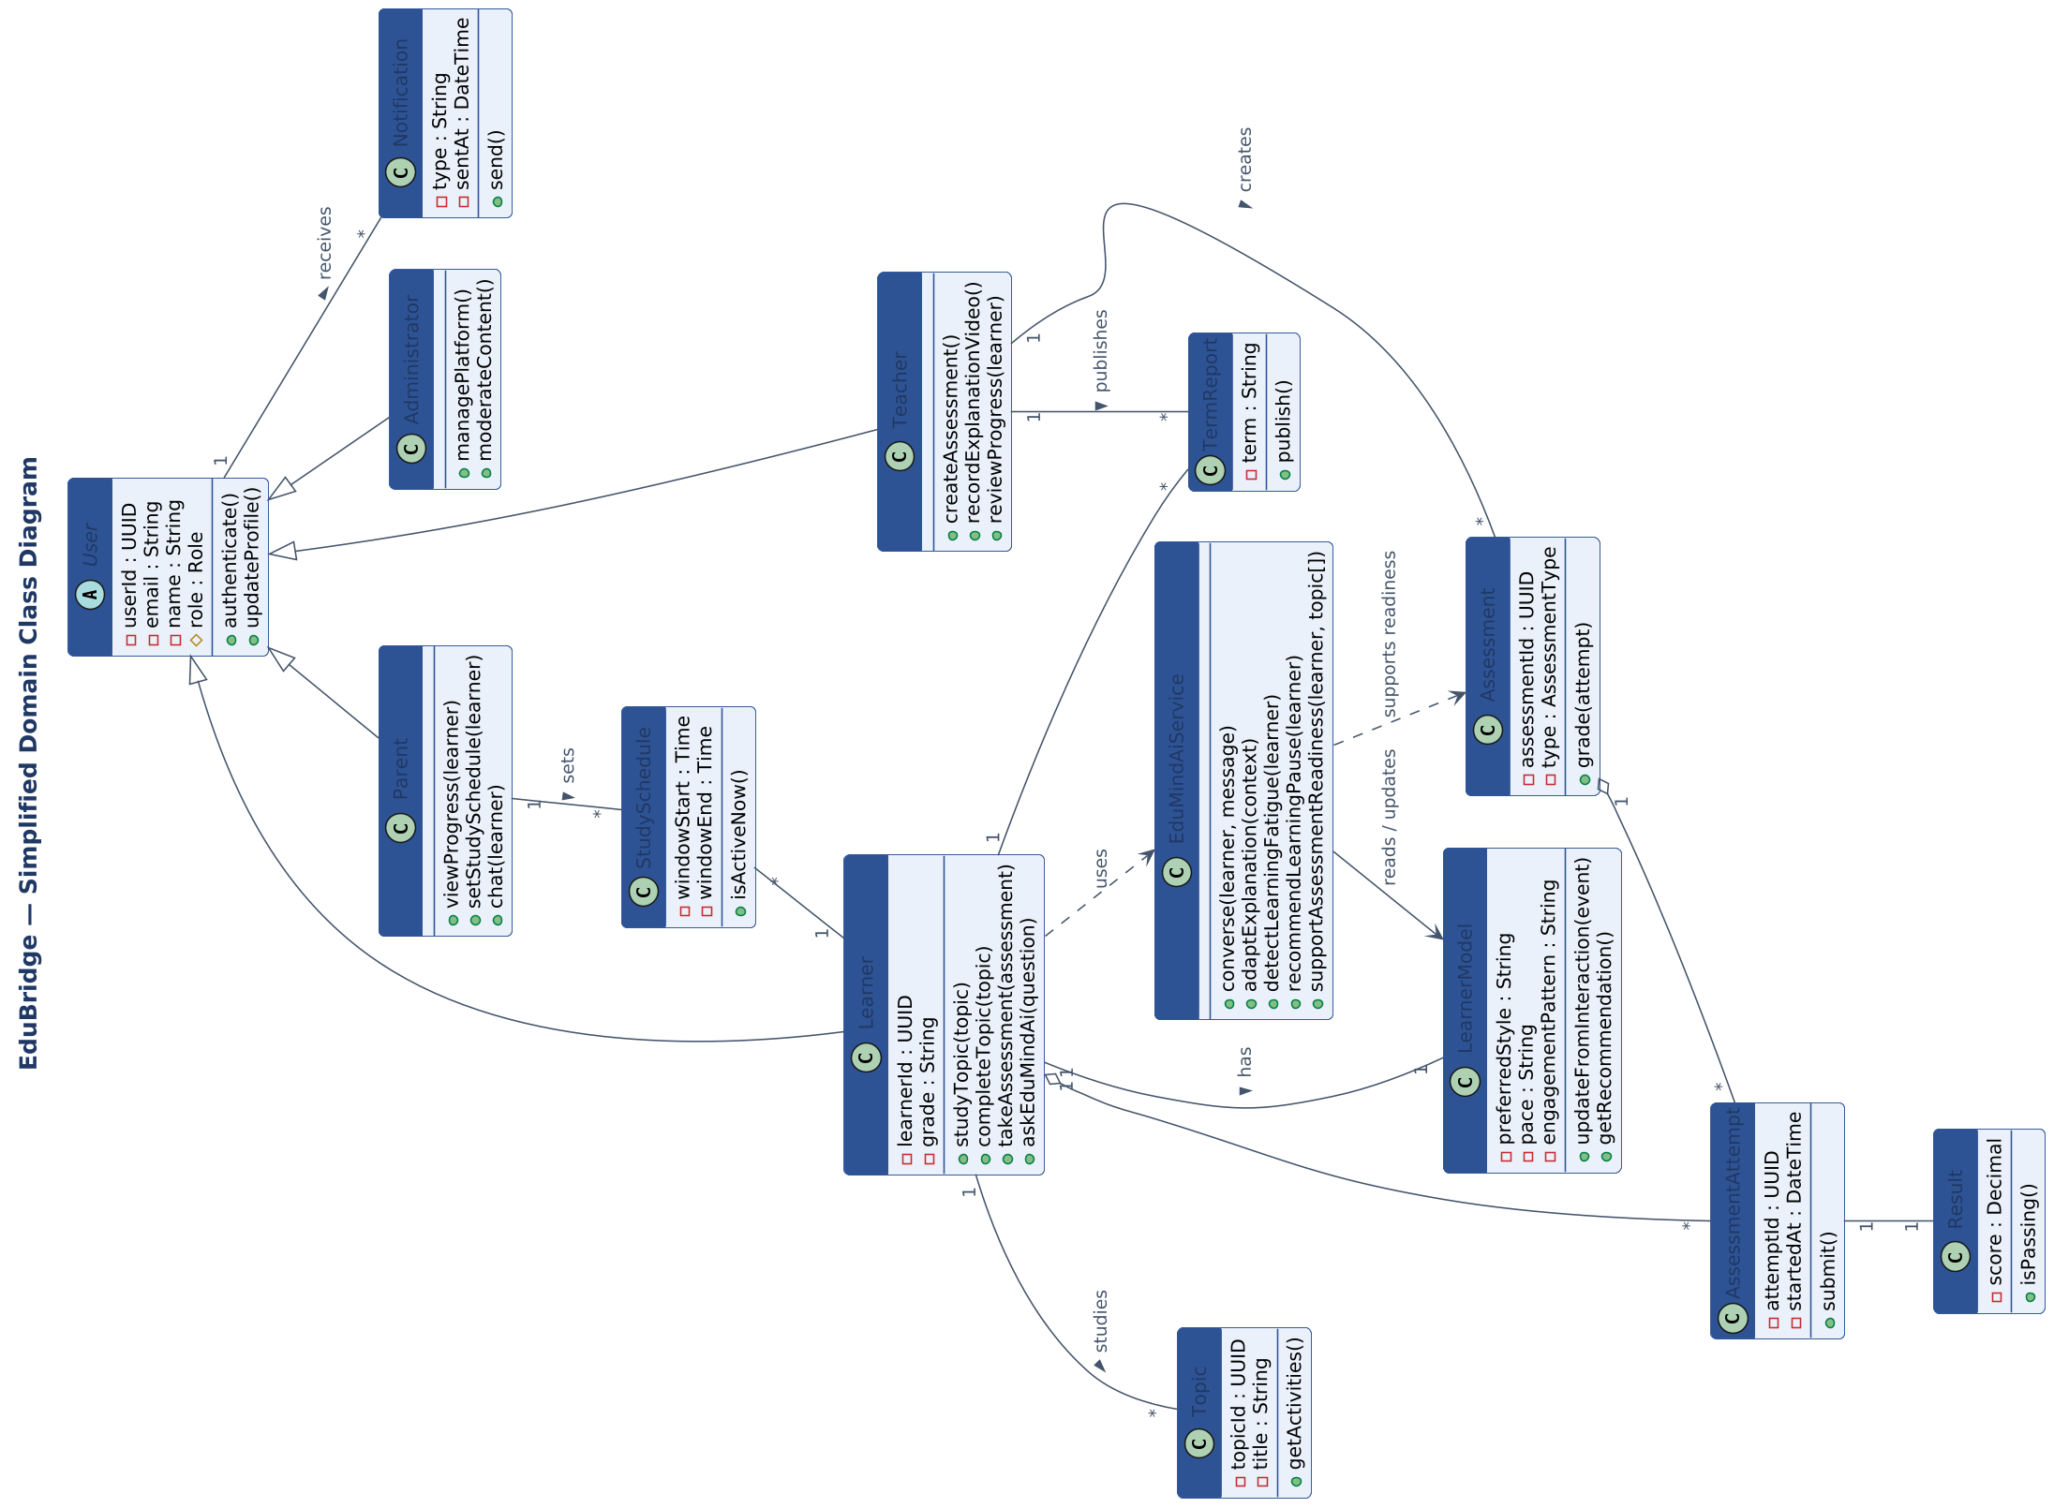
Figure A.9. Illustrative object-oriented view of key domain classes, complementing the ERD with behaviour (methods) relevant to the Learner, Teacher, Parent and EduMindAi roles. Page rotated 90° to maximize print size.

Sequence Diagram: EduMindAi Tutoring Conversation
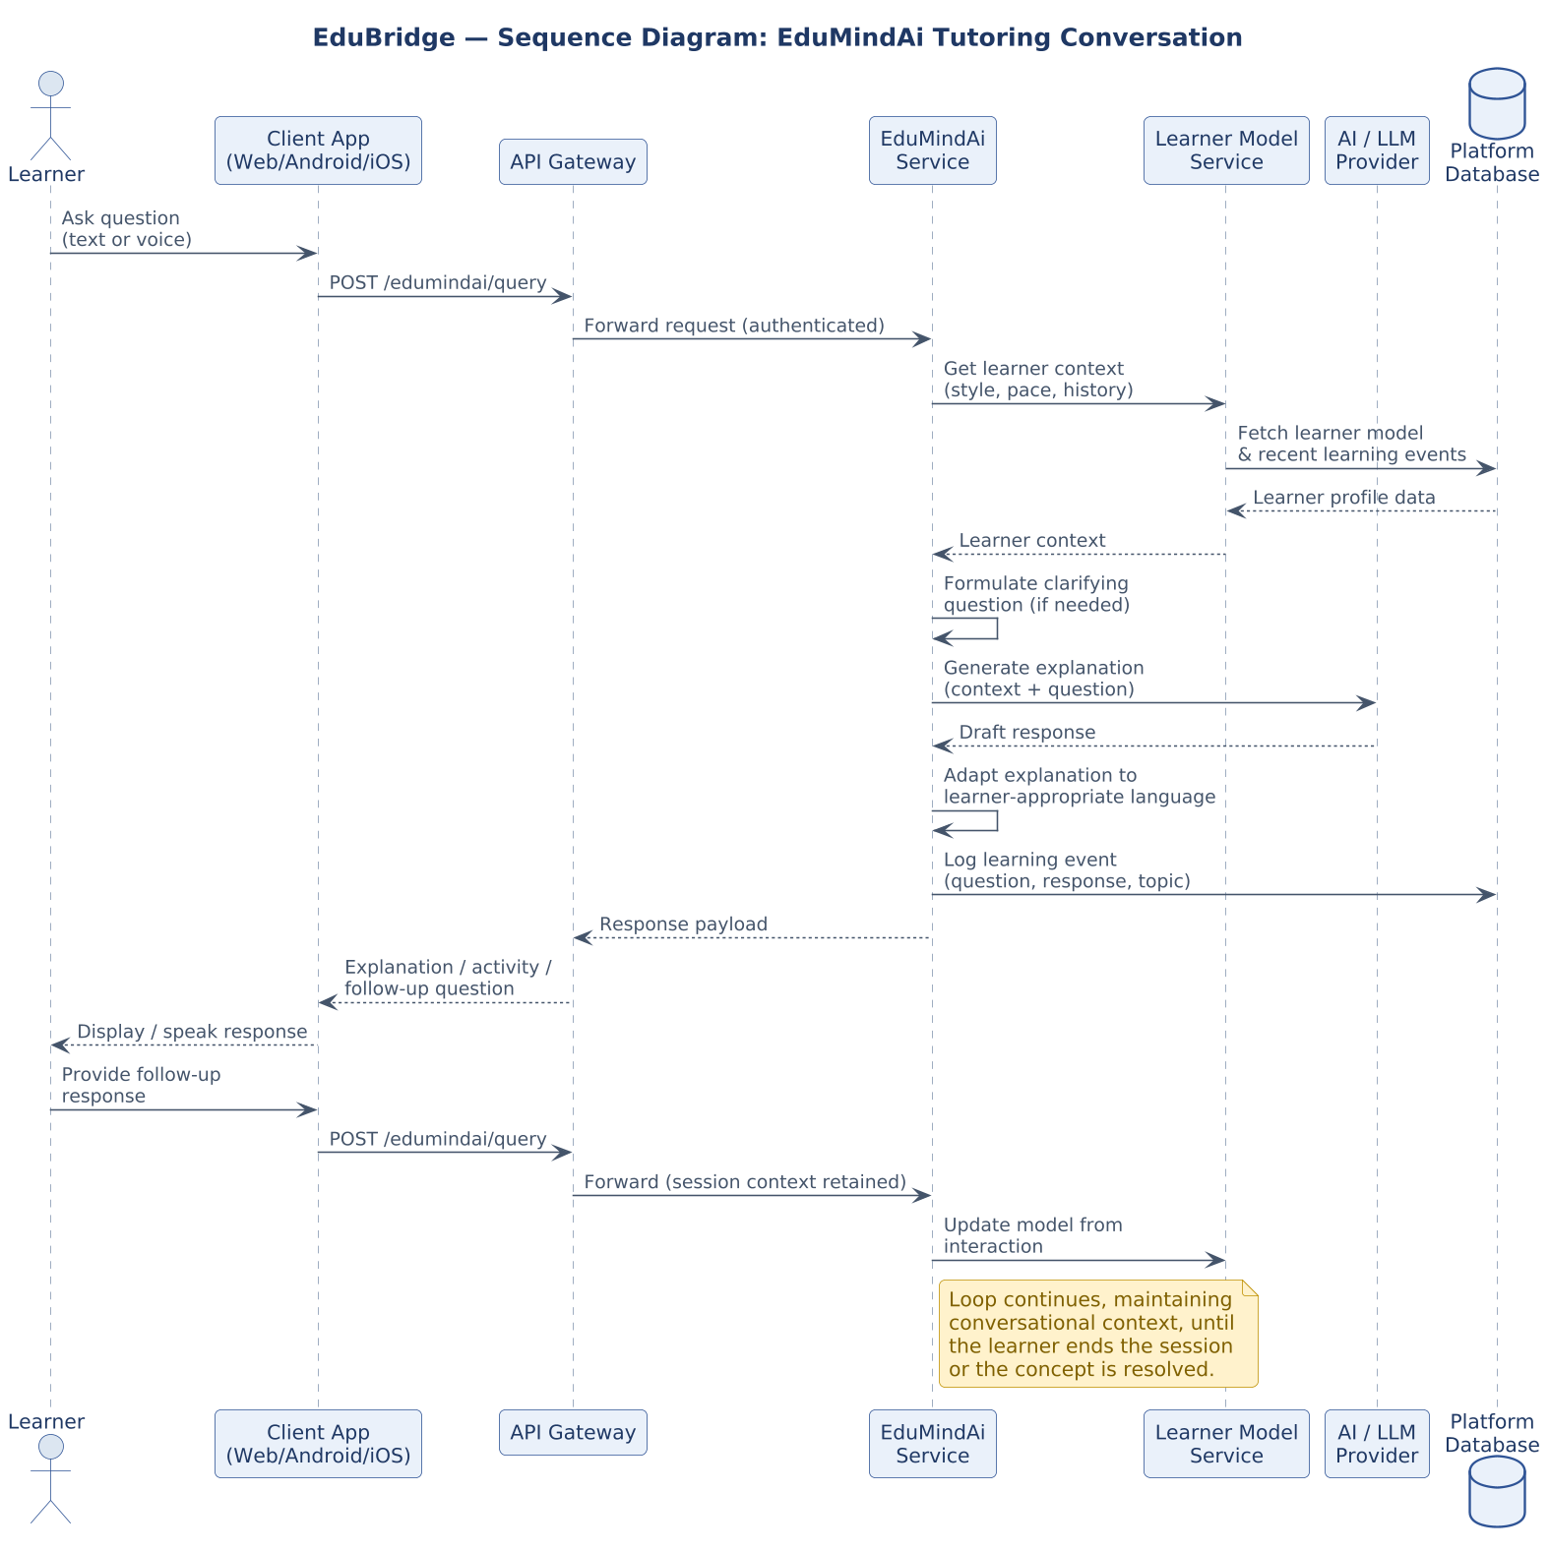
Figure A.10. Interaction flow for a learner question answered through EduMindAi, including learner-model context retrieval and AI/LLM provider inference (Section 7.2).

Sequence Diagram: Assessment Completion, Analytics & Notification
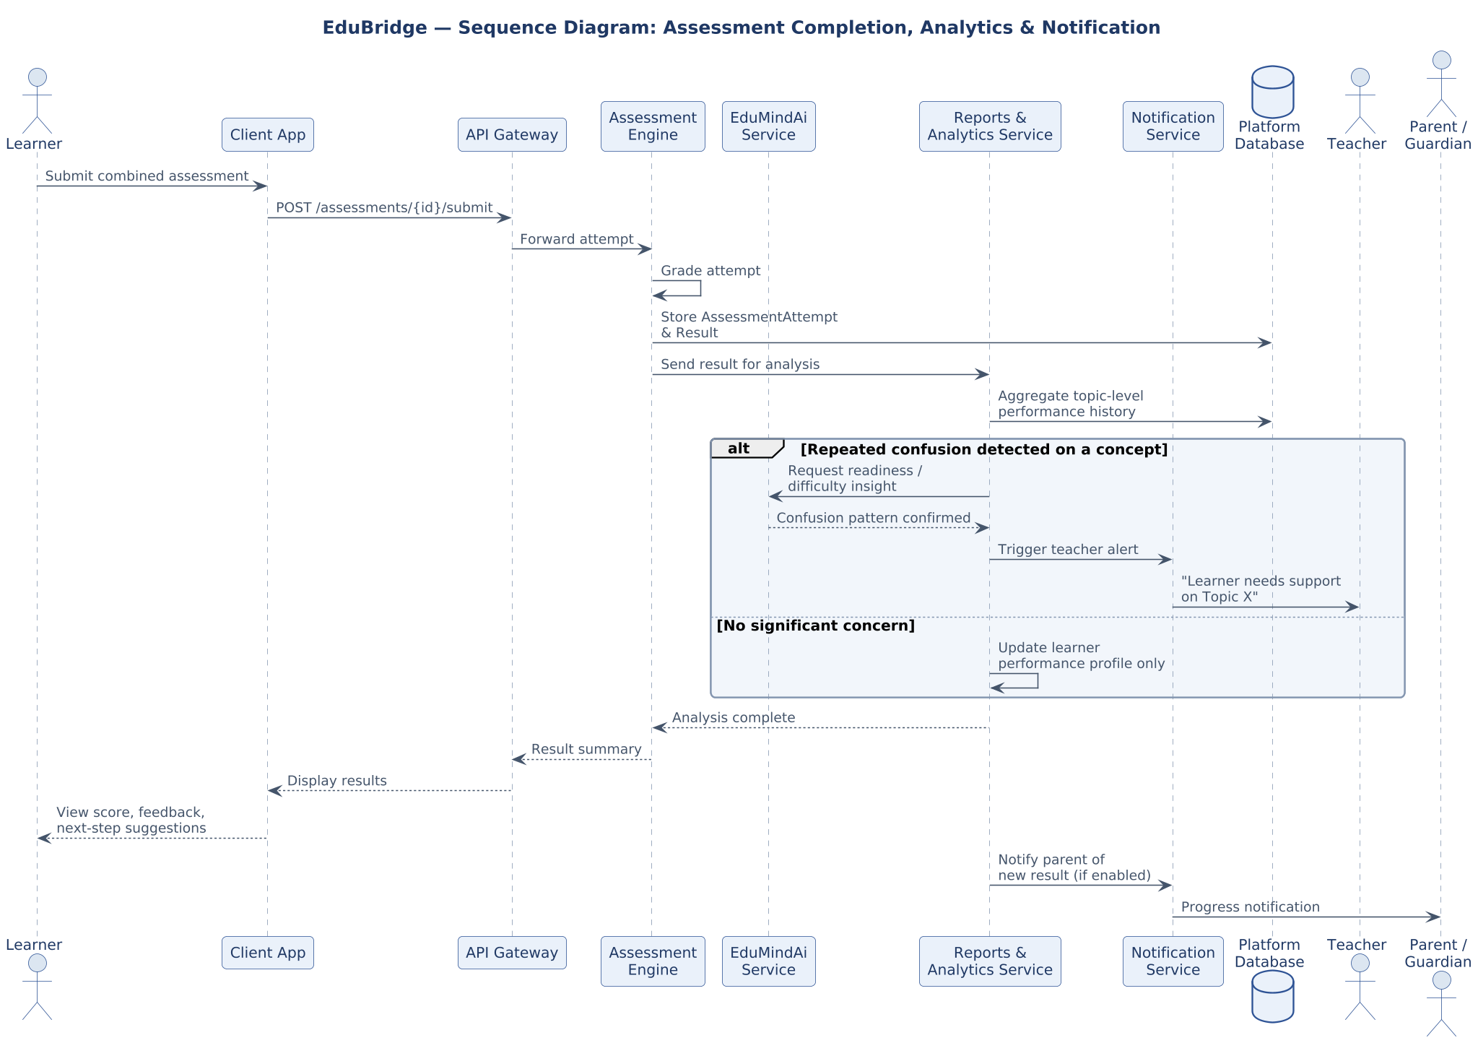
Figure A.11. Interaction flow from assessment submission through grading, analytics, the teacher confusion-alert path, and parent progress notification (Sections 9–10, 12).

